**Hammer Stream Farmer Participation Project Final Report for Natural England CSF**

**Reference No. PO880495**

**A Collaborative Project of the Arun & Rother Rivers Trust (ARRT) and the Catchment Sensitive Farming (CSF) Programme**

**Date: 28th March 2013**

1. **Introduction**
   1. **Project Background**

The pollution of watercourses can arise from a range of sources and activities, varying from industrial outputs and treated sewage effluents to various land-use practices, including farming. These can be both point source and diffuse in nature. Diffuse pollution by its very nature is not concentrated or localised in origin, so that individual

sources can appear insignificant by the originator (or ‘polluter’), which typically makes it harder to control and manage. Agriculture is not the sole cause of diffuse pollution but it does contribute to approximately 60% of nitrates, 25% of phosphorus and 70% of sediments entering our watercourses (Defra website [www.defra.gov.uk).](http://www.defra.gov.uk/) There is national and European legislation (e.g. the Water Framework Directive (WFD)) in force that aims to prevent any further deterioration in water quality, and to protect and enhance the ecological status of all rivers, lakes, groundwaters, estuaries and coastal waters.

The UK Government’s Catchment Sensitive Farming (CSF) programme, administered by Natural England and formerly known as the England Catchment Sensitive Farming Delivery Initiative, covers 65 Priority Catchments across England where, based on the available evidence, pollutants derived from agriculture (e.g. nitrates, phosphorus, pesticides and sediment) are deemed a particular cause for concern. CSF officers work with a range of local individuals, partners and organisations to help identify, manage and reduce diffuse agricultural pollution. The local Arun & Rother Rivers Trust (ARRT) is also working to improve the water environment and is currently hosting the development of the Catchment Management Plan (CMP). Taking a catchment wide approach to issues such as diffuse pollution is critical due to the individually minor but collectively significant nature of such pollution. The Arun & Rother CSF officer (Greg Howarth) approached the Arun & Rother Rivers Trust (ARRT) in the autumn of 2012 to help undertake a farmer/landowner participation project in relation to agricultural runoff in the Hammer Stream, a tributary of the Western Rother. The proposed project was also supported by Tim Clarke, an independent specialist agronomist, Andy Thomas of the Wild Trout Trust (WTT) and John Archer of the local National Farmers Union (NFU).

The Hammer Stream farmer/landowner participation project builds upon previous research work undertaken by Defra on rural diffuse pollution (e.g. Entec 2010), which looked into the merits of non-scientist stakeholders (e.g. landowners, farmers) undertaking self-monitoring as a means of helping to engage/empower local people about the issue of diffuse pollution. Such research sought to ascertain whether meaningful data to help manage the problem could be obtained and to assess whether it encouraged farmers/landowners to take voluntary action or seek out further advice to minimise their diffuse pollution impact.

**Figure 1: Map of the Arun & Western Rother Catchment showing the Hammer Stream Sub-catchment Area**

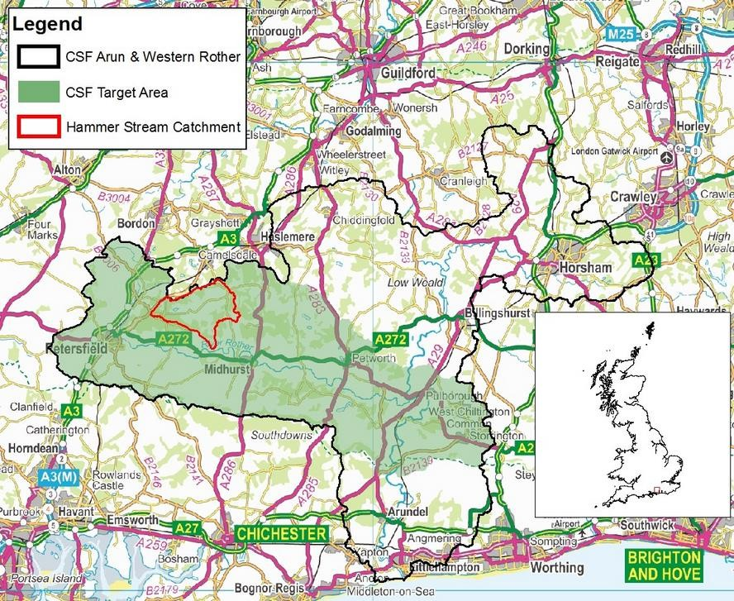

Western Rother

River Arun

* 1. **Project Objectives and Aims**

1. To ask landowners/farmers to monitor on a weekly basis the water quality of their field drains in respect of nitrogen (N) and suspended sediment (SS). Monitoring was to be undertaken across 3 or 4 fields over a 12 week period, from early November 2012 to late January 2013.
2. To assess through the self-monitoring project whether this approach increases local stakeholder awareness, understanding and ownership of diffuse water pollution from agriculture, providing a direct link between agricultural land-use and local water quality.
3. To help understand, through the project, how farmers/landowners respond to information about how their activities affect local water quality (e.g. do they then take up voluntary actions to remediate the effects, or contact CSF/other organisations to help improve performance?).

It is recognised that the data gathered is not likely to be scientifically robust as the monitoring period was over a limited period of 12 weeks, during late winter, and the low- tech/low-cost field kits are neither highly accurate nor precise. The focus of this study is as much about the potential benefits of bringing together local farmers/landowners to discuss the issue of diffuse pollution and what can be done about nutrient leaching and soil/water runoff as it is about the resulting data.

* 1. **Hammer Stream Sub-catchment**

The Hammer Stream is a tributary of the Western Rother, which is an EU Freshwater Fish Directive protected area and comprises part of an important groundwater aquifer, supplying drinking water for the regional South East UK population and contributing to the base-flow of the river. Siltation and deposition of sediment on the river bed is a major fisheries issue for the Rother and is thought to be linked to poor egg survival. Too much sediment in the wrong place leads to smothering of fish eggs and gravel spawning grounds which in turn limits sustainable, healthy fish populations (both in numbers and species diversity) from developing. Concern has been raised in the Western Rother Fisheries Action Plan about declining fish stocks due to poor fry survival (Environment Agency, 2002). This is likely to be a complex issue, including land-use practices and excessive soil erosion, however, low flows could also be exacerbating the problem (Arun & Rother Catchment Appraisal (EA) 2010). Much of the Arun and Rother catchment also fails the WFD for high phosphate levels, which are both diffuse and point source in origin. It is likely that the elevated phosphate levels are partly derived from the agricultural soil/water runoff, some of the phosphate being able to bind to the sediment particles or being in a soluble form. The wider catchment also falls within a designated Nitrate Vulnerable Zone (NVZ), with parts of the Hammer Stream covering both surface and groundwater NVZ’s. There are three drinking water boreholes close to the Hammer Stream, one of which cannot be used as the nitrate (N) levels currently exceed the EU drinking water standard.

The Western Rother, including the Hammer Stream, runs through Lower Greensand outcrops that are naturally very susceptible to runoff and erosion, with much of the land adjacent to watercourses falling within some of the highest soil erosion risk classes in the UK (Sear, 1996). The catchment is predominantly arable with areas of intensive outdoor horticulture, permanent grassland and woodland/commercial forestry. The combination of soil type, rainfall, sunshine, temperature and access to water (irrigation) makes this land particularly suitable for arable cultivation. The topography in general is fairly gentle, without steep slopes, but the combination of soil type, land-use/farming practice and slope is often sufficient after rainfall to cause run-off and soil movement from the land which is not effectively mediated by the usual controls such as grass buffer strips and beetle banks. Fieldwork undertaken in parts of the Western Rother valley has shown that runoff will occur at any time when there is considerable rainfall of medium intensity, with larger rainfall events easily leading to the creation of runoff gullies, which then act as pathways for further erosion triggered by lesser rainfall events (*e.g*. three days consecutive rainfall totalling ~19mm rain triggered soil erosion on the 21st February 2007 (Boardman et al, 2009)). Soil erosion in parts of the valley can also be caused when a crop is irrigated by gantry irrigation, (CSF case-study of Western Rother, undated). This situation is exacerbated by cropping and harvesting regimes which tend to leave relatively open soil on the fields during the winter months (*e.g*. stubble crops). It is very important to recognise the economic framework within which most farmers’ operate and how this limits issues such as long-term soil erosion and diffuse pollution from being brought into short-term farm based decision making. For example how a

farmer/landowner decides upon the next years’ field crops against the potential merits of sub-soiling the land or sowing temporary winter crops such as mustard seed (as a means of locking the N into the land over the winter months and reducing soil/water runoff).

Recent sediment fingerprinting work undertaken for parts of the Western Rother has confirmed that farming makes a significant contribution to the sediment load of the Hammer Stream (see Figure 2 below). This information, together with the historic issues of elevated soil runoff in the wider Rother valley, led to the Hammer Stream being chosen for this farmer/landowner participation study.

**Figure 2: Land use within the Hammer Stream catchment and sediment fingerprinting results**

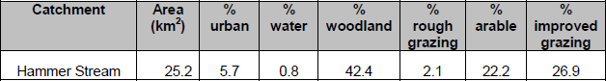

Sediment fingerprinting results:

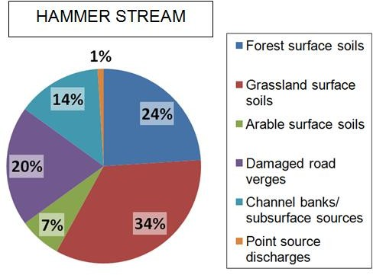

1. **Initial Farmer/Landowner Self-Assessment Workshop**
   1. **Landownership Information and Project Participation**

Information regarding the ownership and usage of land within the Hammer Stream catchment was initially obtained from the CSF officer, via the Rural Land Register (RLR). This revealed 36 separate holdings (*i.e.* registered farms) within the Hammer Stream catchment boundary. A letter of invitation to farmers/landowners was drafted and sent out to each of these 36 prospective project participants in late October 2012. A copy of the invitation letter is provided in the Appendix of this report. Information regarding the event and proposed evening workshop were also posted on the CSF, ARRT, NFU and WTT websites. Following a poor uptake to the written invitation, the CSF and ARRT Project Officers made several follow-up phone calls to help improve farmer/landowner recruitment to the project. It was only after speaking to a number of farmers/farm enterprises that it became apparent that a smaller number of farmers worked across multiple farm boundaries, which meant that the actual number of farmers working the land were more likely to be in the high 20s (rather than high 30s). The exact number is still unknown because not every registered holding was successfully contacted; some did not respond to letters, phone calls or personal visits. Tying to chase all 36 registered holdings within the time allocated for the project proved to be so difficult that a pragmatic decision was taken to focus effort on the larger holdings (especially those of

10 hectares or more) closest to the Hammer Stream, on the assumption that they would have the most active land management practices and therefore the greatest potential to influence receiving water quality.

Thus, given time and data constraints, registered agricultural land holdings of 10 ha or more within the Hammer Stream sub-catchment were targeted for this project, ideally either with land adjacent to watercourses or identifying fields where runoff could relatively quickly reach a watercourse. Woodland/forested land was excluded from the study; CSF can only offer advice to agricultural (not woodland) farms/landowners.

Consequently, 22 farmers/landowners, representing 13 farms/agricultural holdings, attended the ‘Self-Assessment of the Hammer Stream Workshop’ at Milland Village Memorial Hall on Wednesday 7th November, 6-9pm. The percentage and location of farmland in the Hammer Stream catchment represented by participants at the initial workshop is shown in Figure 3 below.

**Figure 3: Location and extent (Ha) of farmland within the Hammer Stream catchment covered by the first farmer/landowner workshop**

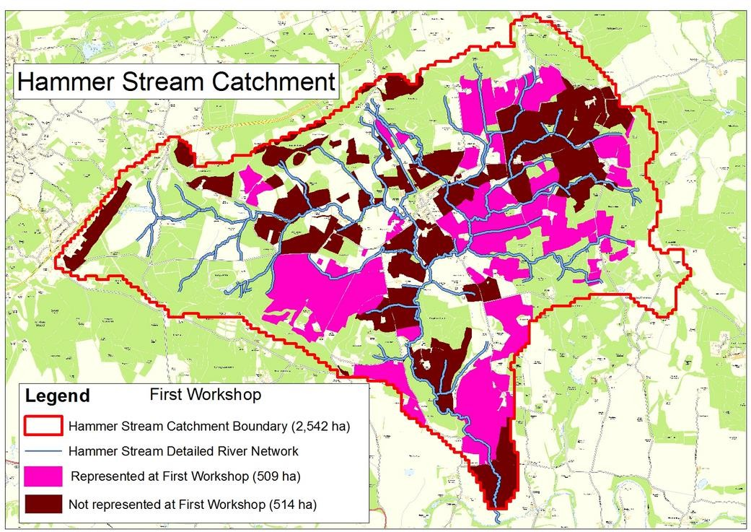

* 1. **Monitoring Objectives and Routine**

It was agreed that self-assessment monitoring for nitrogen (N) and suspended sediments would be undertaken, as these variables lend themselves best to low-cost, low-technical assessment using simple field test kit equipment. During the first workshop, project participants were shown how to use the N testing strips and sediment turbidity tubes and it was explained how the data would primarily be useful in terms of showing the magnitude of the overall results rather than upon data accuracy, and that the end data would be anonymised.

**Figure 4: Map of Hammer Stream farmland undertaking self-monitoring**

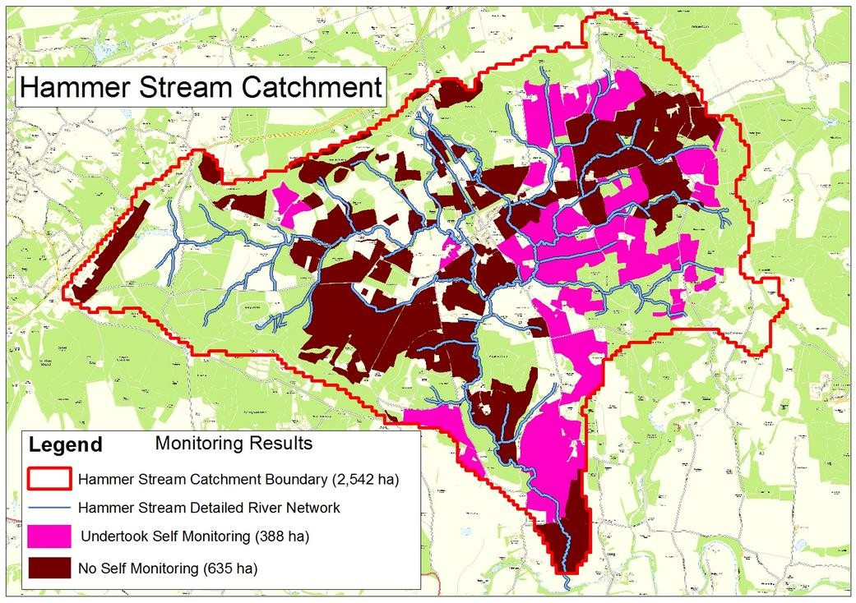

The farmers/landowners were asked to monitor the water quality of their agricultural field drains. If these drains were not present/flowing/accessible then participants’ were asked to monitor any surface water observed over their sample fields. Each participant agreed to monitor 3-4 fields and associated field drains once a week for a period of 12 weeks, from early November 2012 through to late January 2013. It was anticipated that this approach would allow N and suspended sediment data to be compared against different crop types, potentially to manure/fertiliser practices used, and rainfall data.

Farm record sheets where provided for each farmer/landowner, so that they could document information about the farms (crop type, manure applications etc.), mark up on maps the location of monitoring points and record the results, along with any antecedent weather conditions. An anonymised example of a completed farmer’s self-monitoring record sheets are provided in the Appendix, together with the template sheets.

As an added incentive, soil sampling and analysis was also offered by CSF to the participating farmers/landowners, with typically a soil sample analysed for each field monitored. The soil analysis report provided participating farmers/landowners with information on soil nutrient status (P, K, Mg, Ph), soil classification and quality, an assessment of risk, a fertilizer/crop yield assessment and associated recommendations. An anonymised example of the soil analysis results provided to participating farmers is provided in the Appendix.

* 1. **Acknowledgement of Project/Data Constraints and Benefits**

From the outset it was clear that there were a number of project and data related constraints/limitations that should be acknowledged, although it was not considered that these would negate the purpose and outcomes of the study:

* + - Ideally, the self-assessment monitoring period should have been for a longer period of time, to take account of various factors, for examples, different seasonal effects (e.g. rainfall, soil-moisture deficit) and land use management practices (*e.g*. typically manure is applied in the autumn/spring so monitoring after these applications would have provided a better chance of detecting N and suspended sediment peaks; it is likely that most of the N applied to land had been washed out by the time the monitoring was undertaken)
    - The weather for 2012 was a-typical, with a drought taking up the first quarter of the year and the remainder of 2012 breaking all rainfall records
    - The Christmas period fell in the middle of the monitoring period and noticeably effected the data results
    - Once weekly monitoring could potentially limit the usefulness of the resulting data, especially if monitoring was occasionally over-looked, however, it was felt that asking for more regular monitoring would be too onerous on the participants
    - Accuracy of the monitoring data is low when using simple low-cost monitoring equipment. It was important to share this information with participants early on, focussing on the overall aims of the project being to provide a general picture of whether the values recorded where high or low, rather than concentrating on absolute values

Nevertheless, the project presented a unique opportunity to gather land drainage water quality data from different locations in the Hammer Stream sub-catchment. Of equal importance, the project also educated stakeholders on how their agricultural activities could impact on the wider environment and what nutrient leaching and soil erosion meant for them as individual farmers/landowners. The involvement of the ARRT was perceived to be positive, in that they are a neutral body distinct from any regulatory authority and with good local knowledge and landowner contacts. The Chairman of ARRT (Sebastian Anstruther) introduced the workshop and encouraged farmers/landowners to participate in the self-monitoring project. The ARRT Project Officer was directly involved in assisting the CSF Officer with the promotion and delivery of the project, in addition to the production of the final report.

**Figure 5: Photographs of the Initial Self-Assessment of Land Drainage Workshop, at Milland Village Hall, 7th November 2012, 6-9pm.**

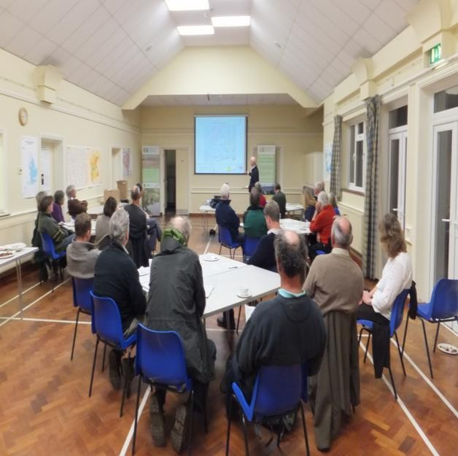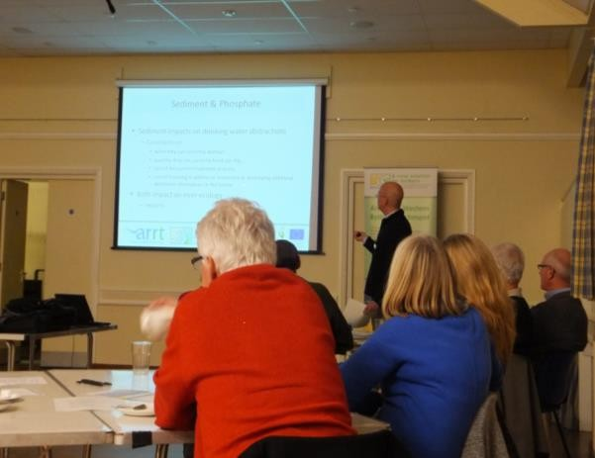

Photo Ref: Serena Leadlay, Natural England, 2012

* 1. **Initial Workshop and Farmer/Landowner Questionnaire**

At the end of the successful initial workshop farmers/landowners were asked to complete a CSF questionnaire which comprised six questions. Eleven completed questionnaires were received, with all data anonymised. Not all the questions were answered by all the

respondents. The summarised results of this questionnaire are portrayed in pie-charts below, except for Question No.3 that asked farmers to identify particular activities which they thought contributed to nitrates (N), phosphates (P) and suspended sediment entering the watercourses. This was answered very qualitatively and focussed upon the inherent susceptibility of the land to soil erosion as a key problem rather than the farming activities that result in N, P and sediments entering the local watercourses.

Forestry was also mentioned by two farmers as contributing to local soil erosion and subsequent nutrient and sediment runoff to local watercourses.

**Figure 6: (Q1) To what extent do you feel that agriculture contributes to nitrates, phosphates and sediments in watercourses in your catchment area?**

A great deal A fair amount A little

Not at all Don't know

The response to the first question revealed that the majority of farmers/landowners at the first workshop considered agriculture contributed either ‘a great deal’ or ‘a fair

amount’ to N and sediments entering the Hammer Stream. It would therefore appear that there is a strong understanding between the local farmers/landowners of the link between agriculture and diffuse pollution. What is perhaps less clear is the significance of diffuse pollution to individual farm enterprises; is it viewed as an externality which cannot be effectively costed by the farmer?

**Figure 7: (Q2) What types of agricultural products do you think are the main causes of these elements in water in the Hammer Stream catchment? (tick more than one if appropriate)**

Pesticides Sewage Slurry/Manure Soil Erosion Fertilisers Don't Know Other

Respondents to the second question identified soil erosion and fertilisers as the two largest causes of N, P and sediments entering the Hammer Stream watercourses, followed by pesticides, slurry/manure applications and sewage. The question itself is of

interest, in that soil erosion is described as an ‘agricultural product’ when it could be argued that it is a by-product of agriculture whose costs are not included as part of farm production. It can be seen that soil erosion is viewed by many farmers/landowners as a key pathway by which N, P and sediments are transferred from the land to the surrounding watercourses.

**Figure 8: (Q4) To what extent do you feel that measures to reduce poor water quality will also help reduce overall farm costs, for example on fertiliser? Would you say…**

A great deal A fair Amount A Little

Not at all Don't Know

The results from question 4 indicate that approximately half of all farmers/landowners saw measures to reduce poor water quality as potentially helping ‘a little’ towards reducing overall farm costs, with around a third perceiving that it could contribute ‘a fair amount’. This result is slightly ambiguous as it is not totally clear what respondents mean by ‘a little’ – whether they saw it as largely insignificant from an economic standpoint or whether it was viewed as contributing in a small yet positive way towards their economic prosperity. This indicates that the relationship between farm crop yield (and by inference farm enterprise profitability) and sediment and nutrient loss needs to be much clearer to incentivise the individual farmer/landowner to reduce, or better manage, surface water runoff.

**Figure 9: (Q5) How well informed do you feel about ways you could adapt your farming methods to prevent or reduce poor water quality in your catchment area?**

V.Well Informed Fairly Well Informed Not V.Well Informed Not Informed At All Don't Know

The results from question 5 imply that farmers/landowners feel fairly well informed about how they could adapt their farming methods to prevent/reduce poor water quality in their catchment. This perhaps again underlines both the lack of economic argument for them to realise this in practice at the farm gate and the high-risk nature of the local soils to erosion.

**Figure 10: (Q6) Do you feel well informed on where to get advice/funding for improvements to farm management if needed?**

V.Well Informed Fairly Well Informed Not V.Well Informed Not Informed At All Don't Know

Question 6 reveals that the majority of farmers/landowners at the first workshop knew where to obtain appropriate information and advice for farm management. However, around a third of the project participants felt either ‘not very well informed’ or ‘not

informed at all’. This indicates that there is still an underlying need to educate and reach out to the farmers/landowners in the agricultural sector, especially given that the farmers/landowners attending the workshop are already likely to be pro-active to land management and related environmental issues.

1. **Monitoring Data Gathered on Nitrate Levels and Suspended Sediment**
   1. **Self-Assessment of Land Drain Water Quality: Data Gathering and Quality**

Five farm self-assessment data sets were received at the end of the monitoring period, with an additional ‘control’ data set gathered from within the local catchment, taken from a relatively undisturbed wooded copse rather than farmed land. This represents approximately 45% of the farmers who attended the initial workshop. It was perhaps a little disappointing that not more of the farmers from the first workshop proceeded with the monitoring. Of the six monitoring data sets only two have reasonably good continuous data throughout most of the project period. It is also apparent that the festive Christmas period significantly disrupted the data gathering process, as did the snowy weather in January 2013.

If this project were to be repeated then better continuous data gathering is required. This might mean streamlining the number of field drains that are monitored, with the

farmer monitoring only one or two fields per week (rather than three or four), to make the commitment less onerous. The project officer might also need to contact the farmers/landowners on a weekly basis to check how the monitoring is proceeding; this would need to be agreed with the farmers in advance to verify that they are happy to be reminded of the project. Interestingly, most of the farmers at the second workshop showed an interest in undertaking similar exercises over a longer time period in the future. Despite the rather patchy nature of the monitoring process a good range of data readings were obtained for N and suspended sediments from the farms. Rainfall data from the local Environment Agency (EA) rain gauge at Petworth were also obtained and compared against the water quality data. Lastly, agricultural runoff is largely determined by rainfall events – the best data is likely to be obtained just after rainfall. This observation complements the EA’s recent commencement of ‘wet walkovers’ of agricultural land (*i.e*. during wet weather) in the catchment, to better gauge the scale of the problem. It remains to be seen whether farmers would be willing to undertake to try and capture this issue in their monitoring programme.

* 1. **Nitrate Readings**

The range of nitrate (N) readings from the farmers’ data is wide – ranging from 100mg/l down to zero. The explanation behind these highs and lows requires a degree of detective work, which often relates to a number of site variables such as land- management, topography/slope of land, history of fertiliser/manure applications, crop history etc. Two of the five farm enterprises recorded several high N readings (50- 100mg/l) while the majority of the farm N data ranged between 5 to 25mg/l. These latter relatively low N levels observed in surface water runoff complement EA monitoring data for the catchment (T. Clarke, Pers. Comm., 2nd Workshop). The relatively low N levels could be explained by both the weather and timing of the project. The rainfall records for 2012 indicate an exceptionally wet autumn and winter, which would contribute to the enhanced leaching of N from the land. The farmers’ manure applications in the previous autumn would have been largely leached out by the time of the winter monitoring. One of the highest N levels was obtained from field drains in pasture land used for cattle grazing. This could potentially be explained by cattle being close to the field drains, poaching the ground at a watercourse linked to the field drain.

It would be interesting to find out more about the relationship between surface and groundwater N levels for the Hammer Stream sub-catchment, especially as a local Southern Water borehole can no longer be used due to excessive N levels in the drinking water. It is likely that there is a time lag between applying N to land and its long-term retention in local groundwater reserves, which may take many years before levels subsequently drop. What can be said with more certainty is that the predominantly sandy soils of the catchment allow quicker drainage and movement of any chemicals (including manures) applied to land, so the cause and effect relationship is likely to be more direct. The designation of the area encompassing the Hammer Stream as a surface water NVZ, with parts of the lower catchment also falling within a groundwater NVZ means that the application of N to land needs to be carefully monitored and managed and may have long-term implications for the local farming community. The farmers’ N monitoring results are displayed in Figure 11.

**Figure 11: Nitrate monitoring results**

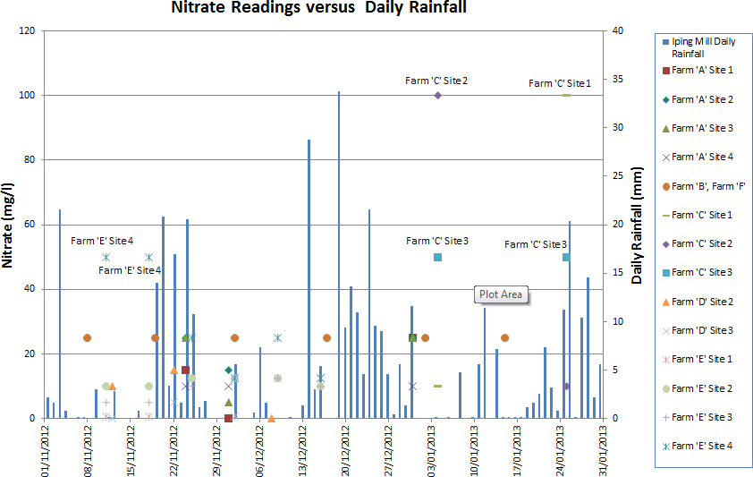

Key:- EU Drinking Water Standard (nitrate): 50mg/l

* 1. **Suspended Sediment Readings**

The range of suspended sediment readings from the farmers’ data is also wide, ranging from ~250 Jackson Turbidity Units down to around 10, with the peaks being represented by different farm enterprises from those with peak N values. There appears to be some correlation between rainfall events and turbidity levels recorded; more regular and longer-term monitoring would help to discern this relationship better.

A couple of farmers mentioned that some of their sampling field drains run directly into watercourses and could not always be accessed for monitoring when water levels were high because the end drainpipe was underneath the water. Interestingly in these fields the surface water levels on the land were not observed to be significant, indicating that the field drains are working well in terms of draining the land, however, this might also be exacerbating nutrient and sediment loss from the field. The highest sediment levels were from cattle grazed pasture, which could be explained by cattle poaching of the watercourse and adjacent land that then results in elevated soil runoff. A longer time series of data would improve our understanding of the relationship between rainfall, field drainage systems, land use and associated soil runoff. The farmers’ sediment monitoring results are displayed in graph form in Figure 12.

**Figure 12: Sediment monitoring results**

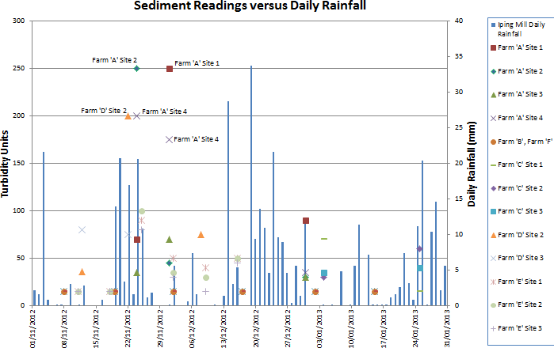

Key: EU Freshwater Fish Guideline Standard: 25mg/l

The Palintest Turbidity Tubes used for the suspended sediment monitoring are calibrated by the Department of Public Engineering, University of Newcastle-upon-Tyne. The calibrations are such that the graduations on the side of the tube may also be taken as being equivalent to the suspended solids content as milligrams per litre. There are no firm regulatory limits for suspended solids, however, the EU Freshwater Fish guideline standard is superimposed upon the self-monitoring results (above), and it can be seen that the majority of data readings breach this recommended guidance limit value.

The impact of elevated soil runoff on the water environment was explained to the farmers at both workshops. This focussed on the problems that increased sediments pose to a river environment, in particular, the smothering of suitable gravel beds for hen fish to be able to use for spawning - thus reducing the number of eggs that can be laid. Increased sediment on the river bed *after* spawning has occurred can also limit the oxygen supply needed for the fish eggs to survive, again reducing fish populations from developing sustainably over time. Research has also been conducted on the effects of turbid water on the ability of fish to search effectively for food, impacting upon their long-term survival. Increased siltation in a river can also potentially smother submerged vegetation which is critical for creating oxygen via photosynthesis. High turbidity rates in water have also been linked to increased pathogen levels with consequent implications for drinking water abstraction and management (e.g. Oregon Dept. Environmental Quality, 2010). Increased turbidity levels in rivers can also raise water temperature,

which can reduce oxygen levels, which in turn directly affects living plants/animals within the watercourse.

The direct nutrient loss to farmers’ fields from soil/water runoff was also discussed in detail. There does not appear to be good local quantified data on the amount of topsoil lost during rainfall events and the associated amount of fertiliser/pesticide lost to the field and thus the impact on crop yield and farm profitability.

**Figure 13: Farmland represented at Second Workshop**

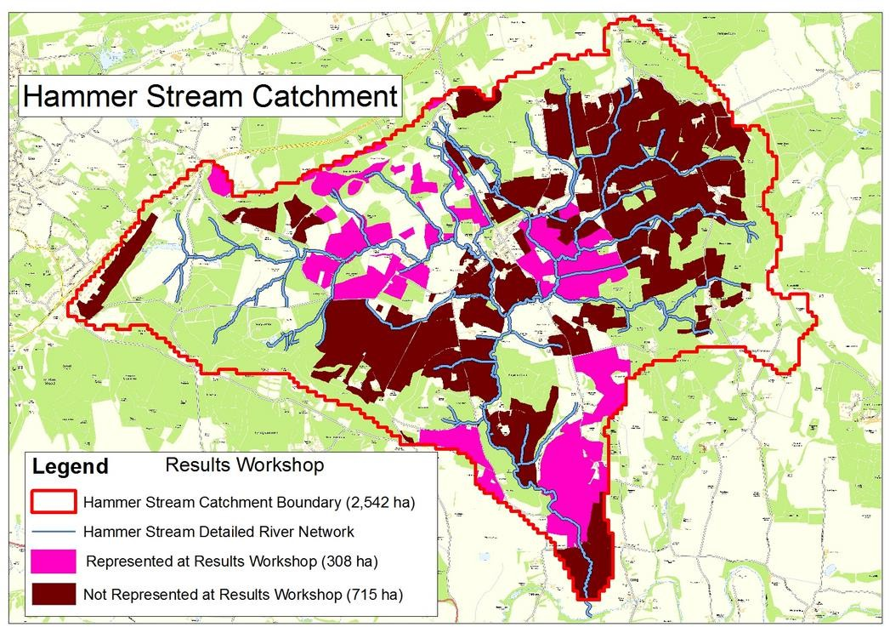

1. **Summary**

The project was structured such that it aimed to clearly show the potential direct benefits for the farmer/landowner as well as for the wider environment of reducing soil/water runoff. This approach was supported by the additional soil analysis service provided to individual farmers who undertook the monitoring, along with recommendations on how to improve yield and prevent nutrient leaching. While the N monitoring didn’t fully reveal a clear relationship between soil concentrations and field drainage concentrations from soil leaching (partly due to the timing of the project and unusually wet and cold weather), the impact of rainfall on turbidity could be seen, and interesting conclusions could be drawn from both data sets.

By including farmers/landowners in the monitoring process they could discuss their own water quality samples and review the factors that influence nutrient and sediment loss through leaching and subsurface runoff. There is a more useful exchange of information from both sides; the farmers find out about the general levels of N for the catchment, the effects of local topography, climate, soil-types and geology on the release and movement of N and suspended sediment from their fields to the wider environment and the implications of this, for example, its impact on NVZs, drinking water abstraction, the

meeting of WFD standards for individual waterbodies within different sub-catchments, and the recognition of the importance of controlling agricultural runoff from a regulatory standpoint. Similarly, CSF, RTs and agronomists learn more about the role and

effectiveness of land drains in the catchment and how farmers’ might struggle financially to incorporate changes to help limit sediment runoff or reduce N leaching. The main topics discussed at the second farmers/landowners meeting comprised:

* Soil type and inherent susceptibility to erosion
* Over-winter rainfall and land use management
* Uptake of N from pasture, cereal, and other crops
* Manure and slurry applications in addition to or instead of short over-winter cover crops such as mustard seed

In addition, the need to include the consideration of phosphate (P) levels in the catchment, as well as N, and the application, uptake and leaching of this important nutrient was acknowledged at both workshops.

If more robust self-monitoring monitoring data were available it might be possible to reach a more informed position where individual farmers can obtain better quantifiable data on nutrient leaching rates with specialist advice on how costs can be saved (e.g. different crop requirements for N, P; fertiliser rates; economic gains to be made by applying manure at particular times of the year and before certain crops are sown; the role of top-dressing slurries and poultry manures in spring; the potential benefits of sub- soiling the land; how different farm machinery influences N, P and sediment runoff released from the land). It is difficult to show the farmer the long-term economic cost of progressive soil erosion when such costs aren’t internalised in their daily decision making; typically farmers need to cover their existing costs on a relatively short-term basis in order for their farm enterprises to survive. If it were possible to calculate the monetary cost to individual farmers of the nutrient leaching problem then this would help incentivise them to address the problem. Current farm economics are unlikely to accommodate the long-term issue of soil erosion, especially as the costs of off-site damage tends to be borne by others or society at large. At least two of the farmers at the initial workshop highlighted the financial barriers against tackling soil erosion problems.

The benefits of avoiding bare/non-vegetated fields during the autumn/winter months were also discussed at the second workshop. The exposure of bare soil (or poorly vegetated fields, typically with less than 30% coverage) through the autumn/winter months, when rainfall is at its greatest, is a key factor effecting nutrient leaching and sediment runoff from the land. Tim Clarke highlighted the benefits of a ‘quick’ cover crop being sown after the autumn harvest and ploughing it back into the land before the spring sowing season. This cover crop would help retain and enhance the nitrate levels in the soil for the proceeding crop, thereby reducing nutrient leaching, limiting sediment runoff and reducing the need for further fertilizer/manure applications. The

farmers/landowners’ however expressed the additional workload that a cover crop would generate at a busy time of year and the risks involved in sowing and successfully germinating the cover crop. The farmers’ cheaper, practical alternative approach is to leave a stubble crop on the fields (that they argue helps to stabilise soils to a degree, thus reducing the risk of sediment runoff) and apply manure to help maintain nitrate levels in the soil for the next crop.

The majority of farmers at the second workshop showed a keen interest in undertaking future self-assessment monitoring. Most of these farmers thought that the monitoring period needed to be considerably longer, perhaps even running over a full year. This would accommodate the different farming activities that occur at different points throughout the year (e.g. autumn manure applications) and seasonal factors, all of which critically influence nutrient leaching and soil/water runoff rates. Weekly monitoring of one or two field sites per farm enterprise over a longer period of time was therefore a recommendation arising from this study.

Finally, this project shows that involving farmers/landowners with water quality monitoring and empowering them to review local water quality issues in relation to their own data and farm practices is a successful way of engaging with them and increasing their awareness of diffuse pollution. Such an approach provides farmers/landowners with an improved knowledge base, such that if the EA where to contact them they would have their own data to add to any subsequent discussion. This combined approach to environmental improvement alongside supporting more sustainable farming and highlighting potential benefits to the farmer will help foster a partnership approach that is necessary in order to be able to address the diffuse pollution problems arising from agriculture, as required by the WFD and other statutory bodies and standards.

Reporting: Ses Wright & Greg Howarth. Project supported and delivered by Greg Howarth, Tim Clarke, Sebastian Anstruther and Ses Wright (28/3/2013)

**References**

Boardman, J., Shepheard, M.L., Walker, E., and Foster, I.D.L. (2009) Soil erosion and risk-assessment for on- and off-farm impacts: a test case using the Midhurst area, West Sussex, UK. Journal of Environmental Management 90 (2009) 2578-2588

Catchment Sensitive Farming Case Study: Reducing the Impacts of Soil Erosion in the West Rother, Sussex. (Undated CSF report via Damon Block, Southern EA).

Defra website, [www.defra.gov.uk](http://www.defra.gov.uk/)

Department of Environmental Quality, Oregon, (2010) Revising the Water Quality Standard for Turbidity: Draft Issue Paper 26th October 2010.

Entec (2010) Fielding, L. and Smith, R. ‘Farmer Participation in Water Quality Monitoring for Catchment Sensitive Farming: A Pilot Project’. R&D Technical Report WT1301/TR for Defra Water Quality Division.

Environment Agency (2010) Arun & Rother Catchment Appraisal. EA South East region. Environment Agency (2002) Western Rother Fisheries Action Plan. EA South East region.

Sear, D.A. (1996) Fine sediment accumulation in the River Rother, West Sussex. Report to Southern Region NRA by Dept. of Geography, University of Southampton.

Western Rother Fisheries Action Plan (undated) Environment Agency, Southern.

**Appendix**

1. Copy of Invitation Letter sent out to prospective farmers/landowners in the Hammer Stream catchment
2. Copy of the Agenda for the first farmer/landowner Workshop at Milland Village Hall, 7th November 2012
3. Natural England information provided on self-monitoring field test kits
4. Anonymised example of farmer/landowner self-assessment monitoring record
5. Anonymised example of soil sampling service provided to participating farmers/ landowners
6. Table with brief description of farm enterprise for participating farmers/landowners undertaking N and suspended sediment self-monitoring